**Agile Methodology**

**Introduction to Agile Methodology**

Agile methodology is a type of project management process, primarily used for software development, where demands and solutions evolve through the collaborative effort of cross-functional teams and their customers. It promotes adaptive planning, evolutionary development, early delivery, and continual improvement. Agile encourages flexible responses to change.

The Agile Manifesto, created in 2001 by seventeen software developers, outlines the foundational values and principles of Agile software development. These values emphasize individuals and interactions over processes and tools, working software over comprehensive documentation, customer collaboration over contract negotiation, and responding to change over following a plan.

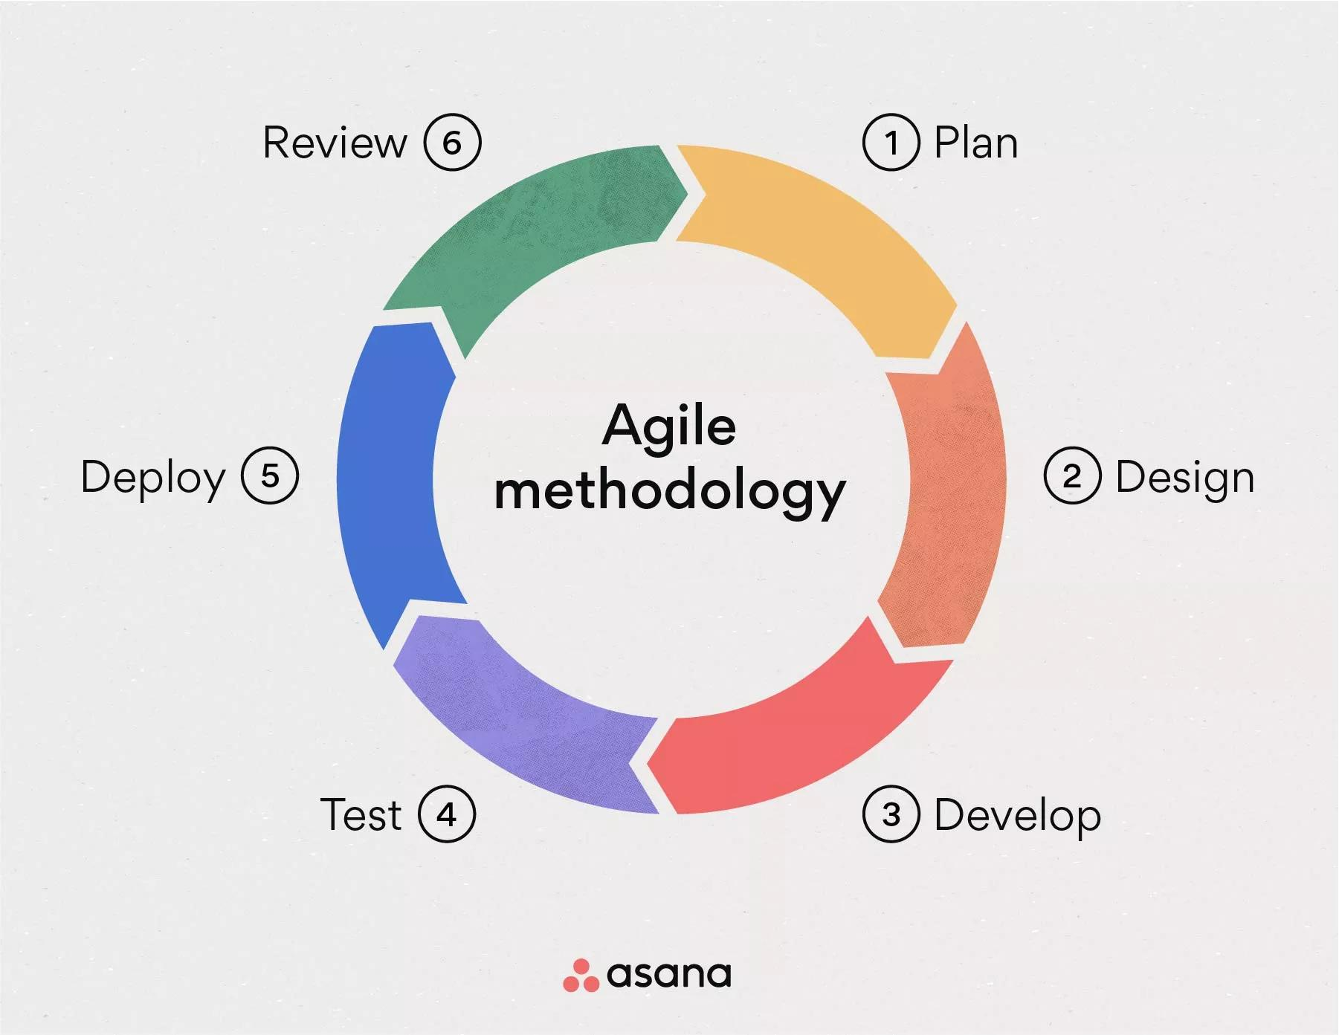

### ****Core Principles of Agile****

Agile methodology is based on twelve key principles:

1. Customer satisfaction through early and continuous delivery.
2. Welcome changing requirements, even late in development.
3. Deliver working software frequently.
4. Business people and developers must work together daily.
5. Build projects around motivated individuals.
6. Face-to-face conversation is the best form of communication.
7. Working software is the primary measure of progress.
8. Agile processes promote sustainable development.
9. Continuous attention to technical excellence and good design.
10. Simplicity—the art of maximizing the amount of work not done—is essential.
11. The best architectures, requirements, and designs emerge from self-organizing teams.
12. Regularly reflect on how to become more effective, then tune and adjust accordingly.

### ****Agile Frameworks****

* **Scrum**: Emphasizes teamwork, accountability, and iterative progress toward a well-defined goal.
* **Kanban**: Focuses on visualizing tasks on boards to enhance work transparency and flow.
* **Extreme Programming (XP)**: Enhances software quality and responsiveness through practices like pair programming and continuous integration.
* **Lean Software Development**: Inspired by lean manufacturing, it focuses on minimizing waste and maximizing value.

### ****Benefits of Agile Methodology****

* **Improved Product Quality**: Continuous testing and feedback lead to early defect detection.
* **Customer Satisfaction**: Frequent deliveries and active collaboration ensure customer needs are met.
* **Higher Team Morale**: Empowered teams that self-organize tend to be more motivated and engaged.
* **Flexibility**: Agile's iterative nature makes it easier to adapt to changing priorities.
* **Faster Time to Market**: Incremental development and regular releases accelerate the delivery process.

### ****Challenges in Agile Implementation****

* **Cultural Resistance**: Organizations used to traditional models may resist change.
* **Lack of Experience**: Inadequate knowledge of Agile practices can hinder implementation.
* **Scalability**: Agile practices may be difficult to scale across large teams or departments.
* **Inconsistent Roles**: Undefined or overlapping roles can cause confusion and inefficiency.

### ****Conclusion****

Agile methodology has revolutionized the way software is developed and delivered. Its emphasis on collaboration, flexibility, and customer feedback makes it an ideal approach for dynamic and fast-changing industries. By adhering to its core principles and selecting suitable frameworks, organizations can achieve improved efficiency, product quality, and customer satisfaction.